|  |
| --- |
| teslaBlog.COM |
| Tesla cars site |
| Tesla car models insight, news and dealership finding |
|  |
| **Dimitar Petrov 337 5471, Class: Ei2B** |
| **2/8/2018** |

|  |
| --- |
|  |

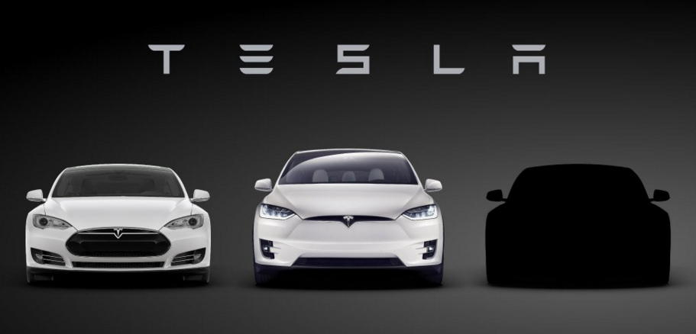

Contents

3.0 Introduction 2

3.1 Target audience 2

Why do they visit your site? 2

What do they want to reach? 2

What information do they need? 2

4.0 Sitemap 3

5.1 Wireframe : Home Page 4

5.2 Wireframe : News 5

5.3 Wireframe : Sign Up 6

5.4 Wireframe : Sign In 7

5.5 Wireframe : Models 8

5.6 Wireframe : Model S 9

5.7 Wireframe : Model X 10

5.8 Wireframe : Model 3 11

5.9 Wireframe : Contact Us 12

6.0 Visual Design: Home Page 13

# Introduction

This document is to provide information about the plan for executing a project of creating a “blog” website concerned with newest inventions in the field of electricity powered cars, more precisely: Tesla brand cars.

# Target audience

## Why do they visit your site?

People visit our site to find the latest information about all Tesla brand cars.

## What do they want to reach?

People want to get access to the latest Tesla company related news and specific information about every model.

## What information do they need?

People would need more information concerning the price, options, discounts, reliability and more about the different brand models.

# Sitemap

**Home**

**Model X**

**Model 3**

**Model S**

**Contact Us**

**Models**

**Sign Up**

**Sign In**

**News**

# Wireframe : Home Page

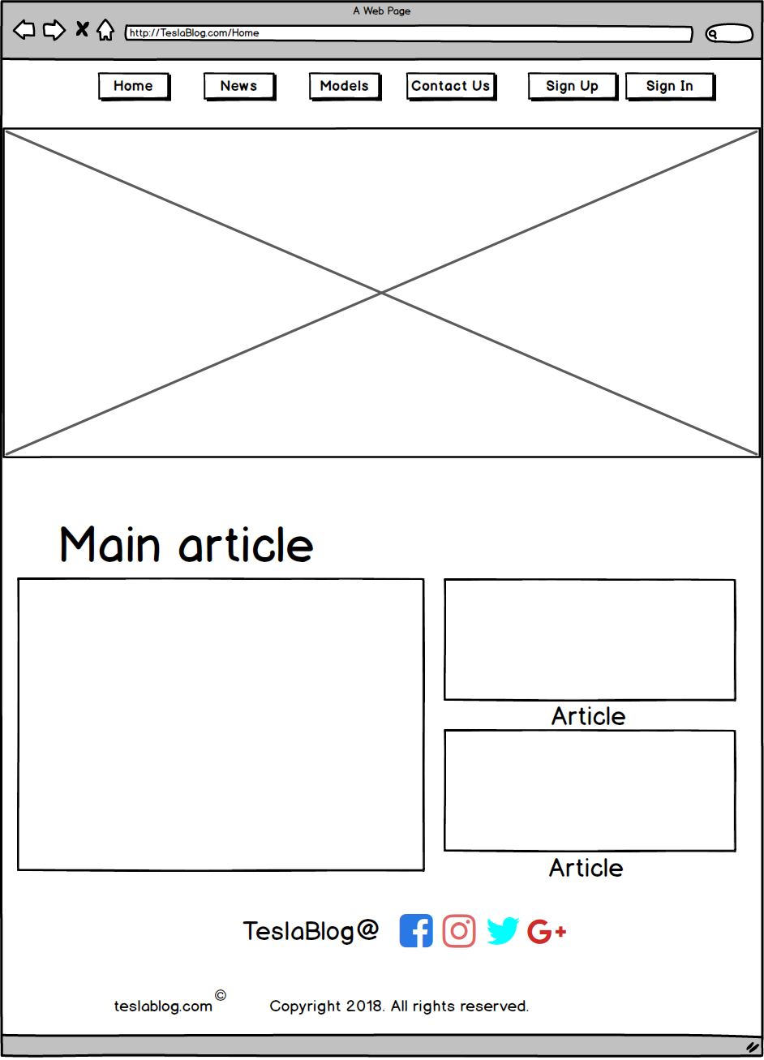

# Wireframe : News

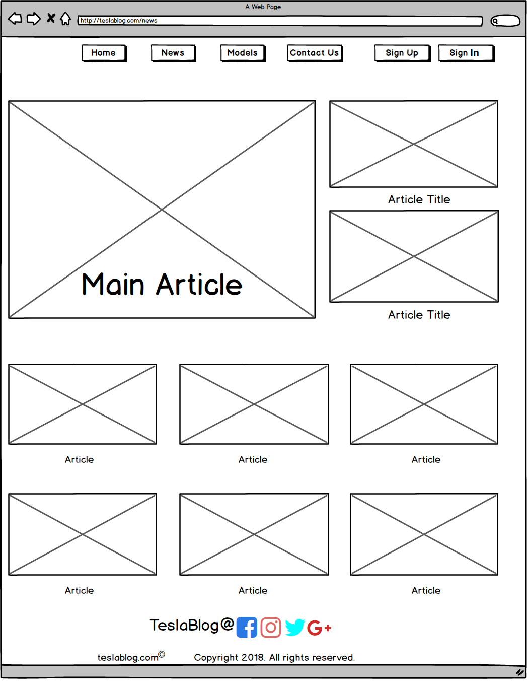

# Wireframe : Sign Up

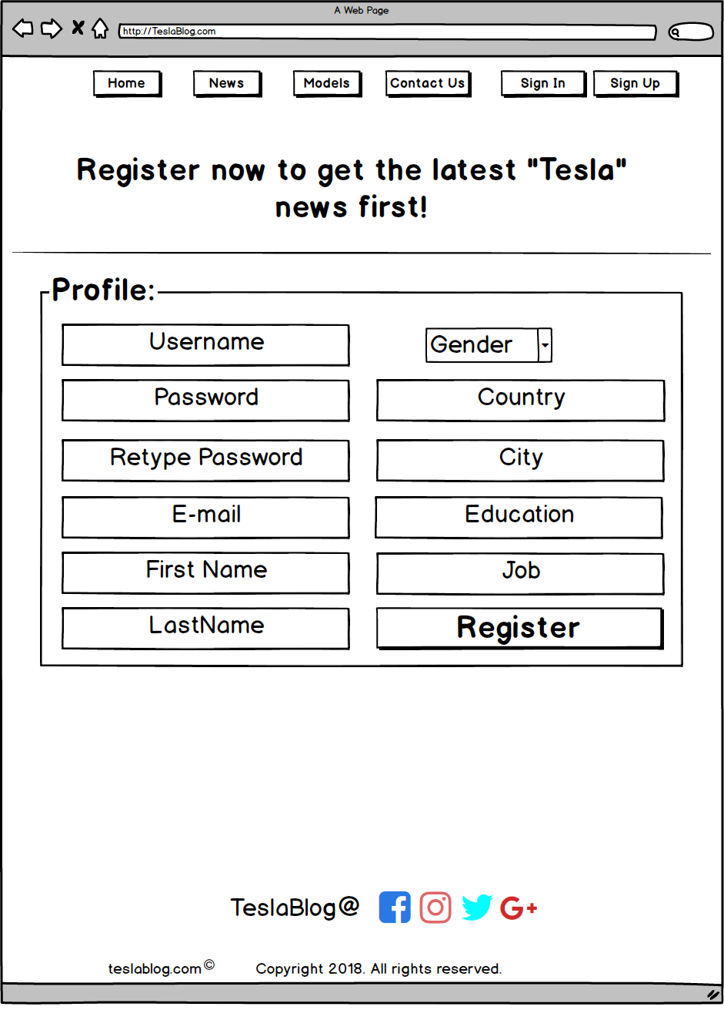

# Wireframe : Sign In

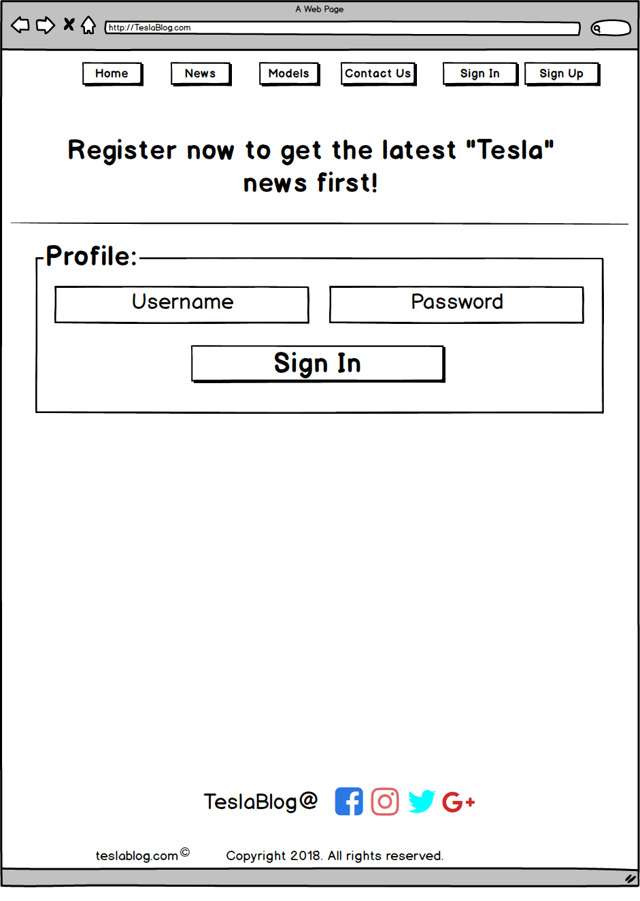

# Wireframe : Models

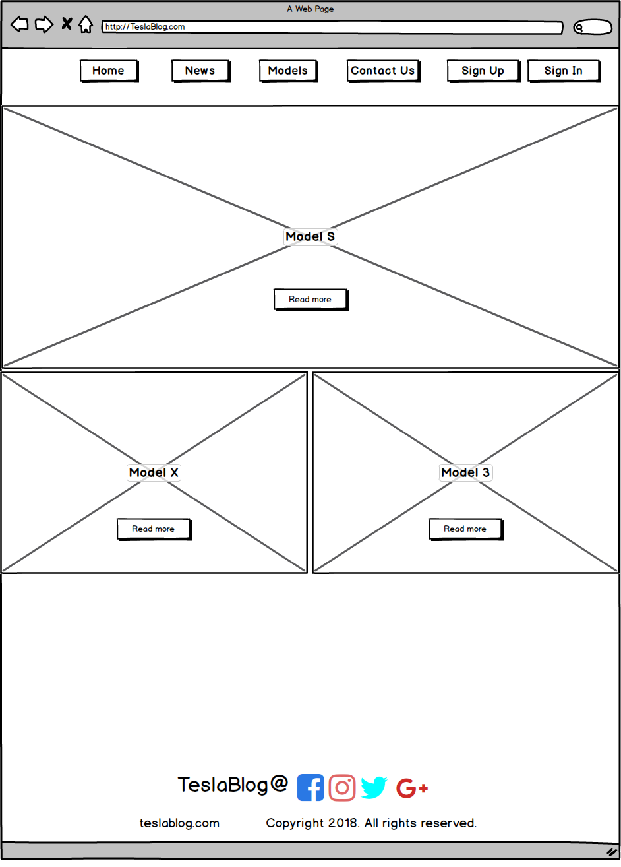

# Wireframe : Model S

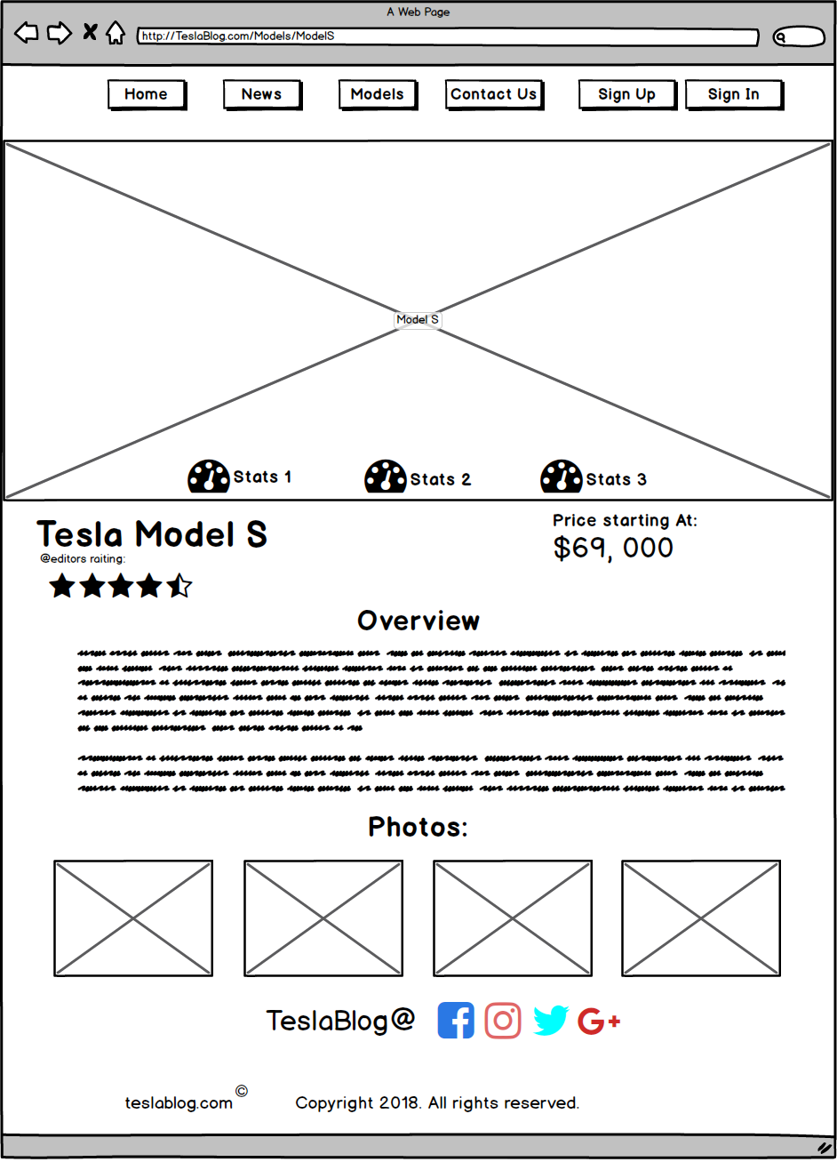

# Wireframe : Model X

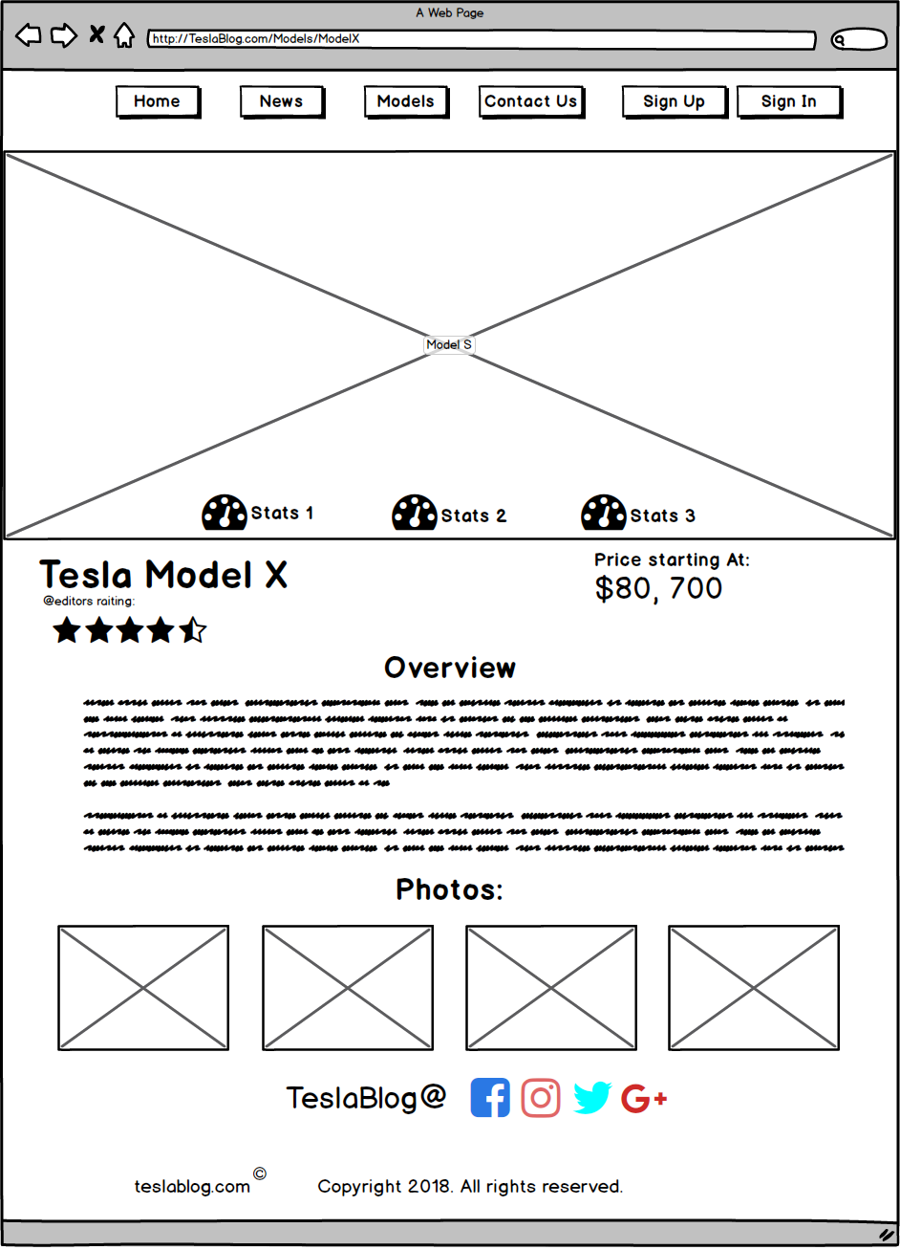

# Wireframe : Model 3

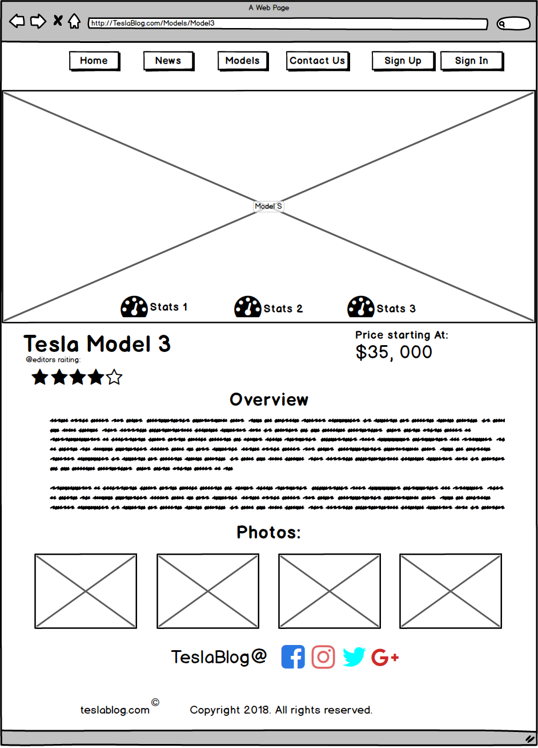

# Wireframe : Contact Us

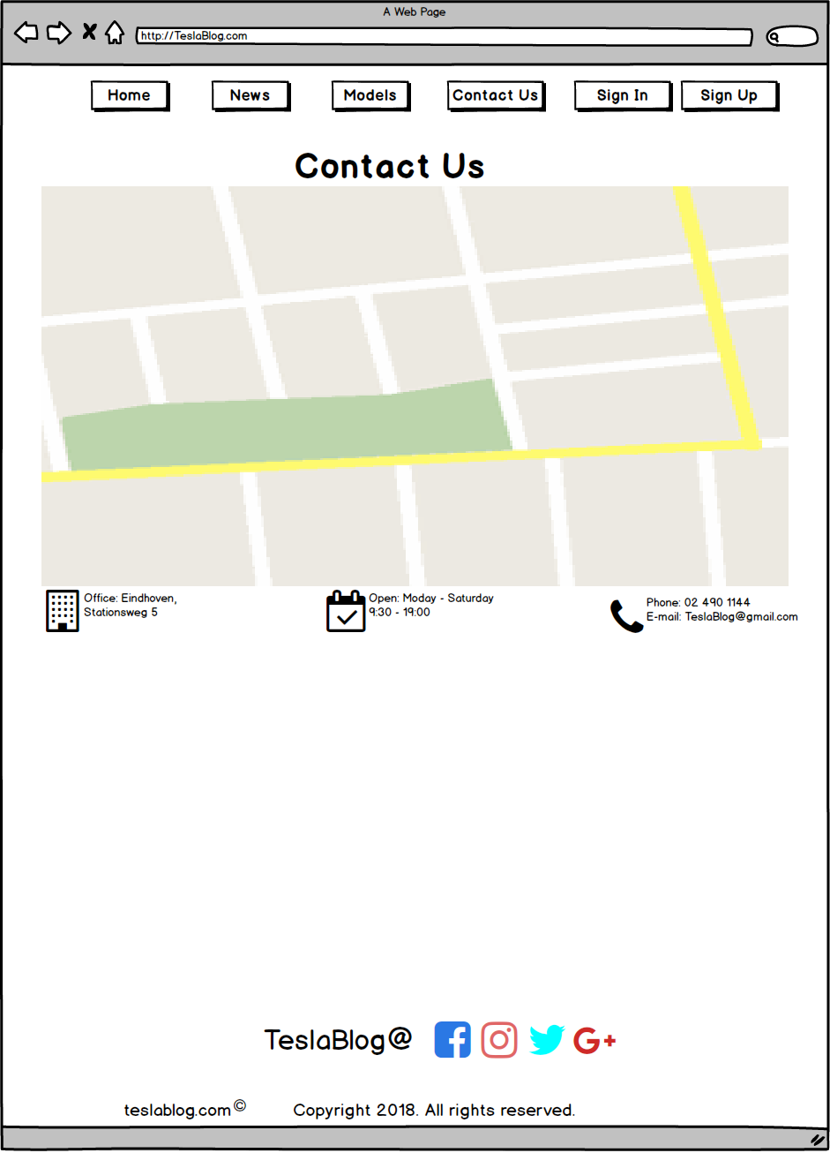

# Visual Design: Home Page

